EE 475 Quiz #12
Name:

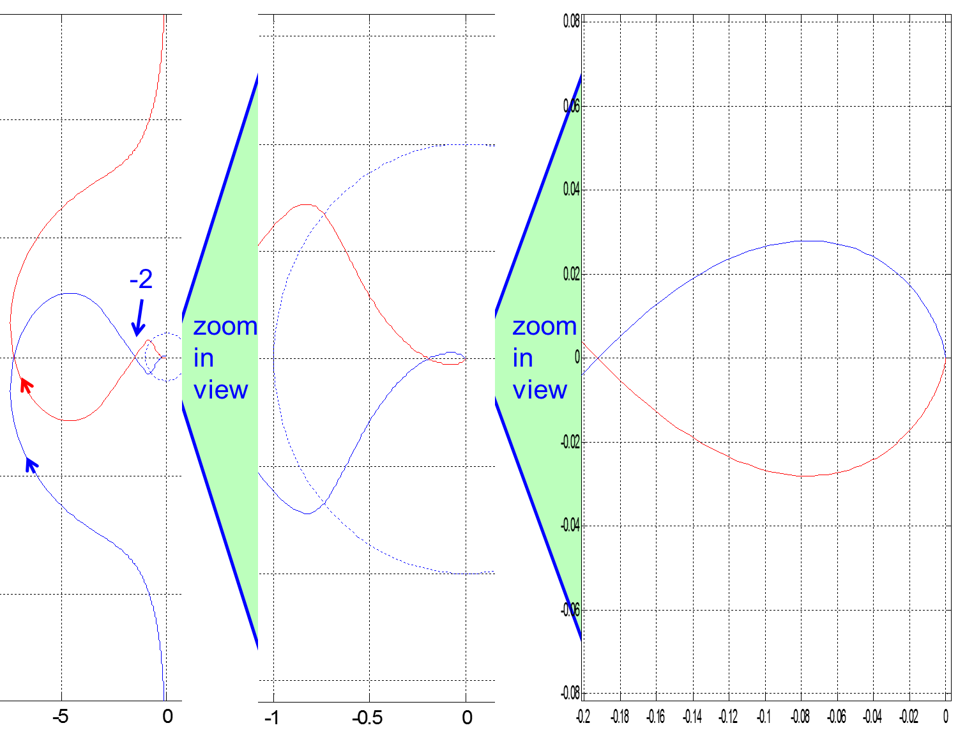

w~=inf

w~=0

Consider the Nyquist plot above left with two levels of zoom-in. Blue is positive frequency and red is negative frequency. Notice the arrows. Open loop system is stable.
- Determine the system type:
w~=inf
- Determine the position error constant:
- Determine the steady state tracking error to a step input:
- Determine the relative order of the system:
- Determine gain margin:
- Determine phase margin:
- Complete Nyquist plot by hand-drawing the part from w=0- to 0+ (add to the left plot).
- Count the number of encirclements N.
- Determine the P= and Z=
- Determine closed-loop system stability:

