EE 475 Quiz #14

Name: Score

Grader:

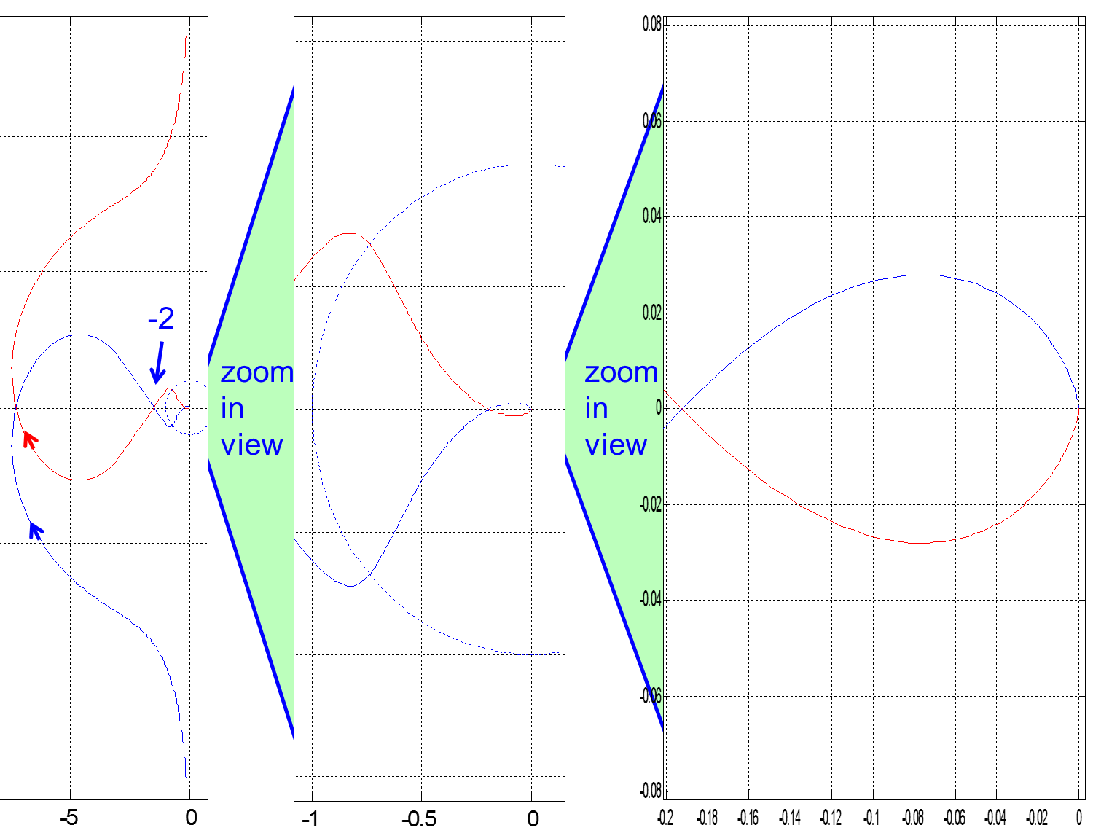

w~=inf

w~=0

Consider the Nyquist plot above left with two levels of zoom-in. Blue is positive frequency and red is negative frequency. Notice the arrows. Open loop system is stable.

1. Determine the system type:
2. Determine the position error constant:
3. Determine the ess to a step input:
4. Determine the relative order of the system:
5. Determine gain margin:
6. Determine phase margin:
7. Complete Nyquist plot by hand-drawing the part from w=0- to 0+ (add to the left plot).
8. Count the number of encirclements N
9. Determine the P= and Z=
10. Determine closed-loop system stability: