EE 475 Fall 2018 Quiz #2
Name: key Score

- The unit impulse response of a system is defined as the system output response when its input = unit impulse and initial conditions = 0 .
- The unit step response of a system is defined as the system output response when its input = unit step and initial conditions = 0 .
- If a system has transfer function H(s),
  - then its impulse response is given by h(t) = L⁻¹( H(s) )
  - and its step response is given by y_{s}(t) = L⁻¹( H(s)/s )
- G1G2
- 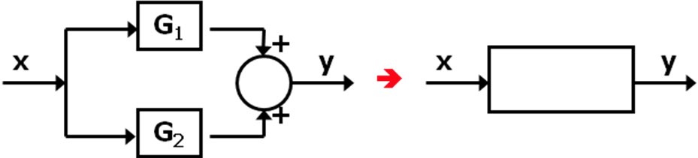G1+G2
- 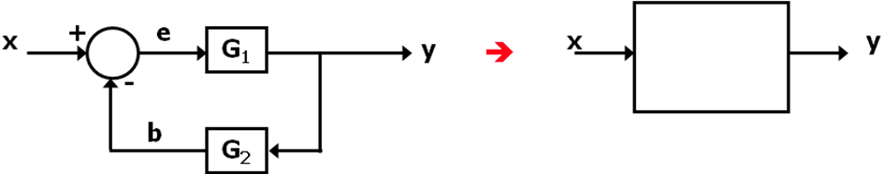G1/(G1G2+1)
- 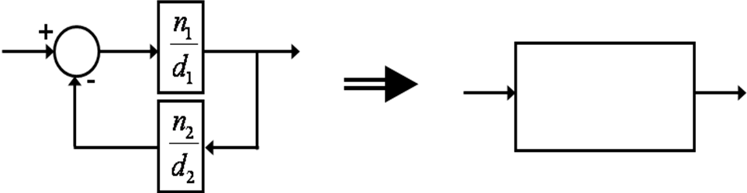n1d2/(n1n2+d1d2)

