EE 475 Quiz #3

Name: Score

Grader:

1. Consider the signal flow graph below

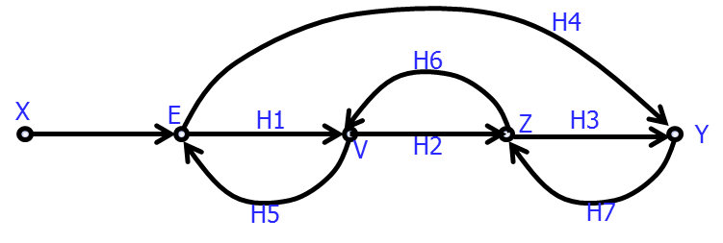

1. There are 4 loops, 3 small ones and one big one. The loop gains are:

L1= L2=

L3= L4= .

1. There is one non-touching loop pair. This pair is: .
2. The determinant of the graph is (write in terms of L’s, no details)

= .

1. There are two forward paths from X to Y. The forward path gains are:

M1= M2= .

1. The determinants of the sub-graphs after removing each forward path are:

1= 2= .

1. The transfer function from X to Y (in terms of the symbols defined above)

TF= .