EE 475 Quiz 8
Name: Score

Grader:

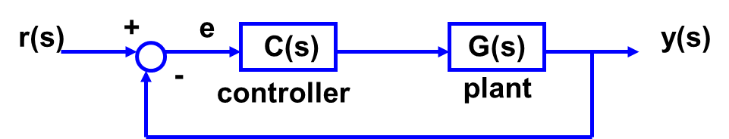
- For a unity feedback control system with open loop transfer function G_{o}(s) and only a reference input r(s),

  - The system type N = the # of in C*G denominator.
  - It is also equal to the # of in C(s)G(s).
  - the position error constant Kp = ,
  - the velocity error constant Kv = ,
  - the acceleration error constant Ka = ,
  - the ess due to a step r(s) is e_{ss2step} = ,
  - the ess due to a ramp r(s) is e_{ss2ramp} = ,
  - the ess due to an acceleration r(s) is e_{ss2acc} = .
  - If system type = 1, e_{ss2step}= , and e_{ss2acc}= .

